****NAME:_____________________________**

**Waves and Quantum Theory Topic Test 2018**

*(52 Minutes + 5 Min reading, 52 Marks)*

**QUESTION 1 (4 Marks) Q1 WATP 2008**

Police “radar” speed guns operate by using the reflective properties an electromagnetic wave of frequency 40 kHz.

(a) What is the wavelength of the wave?

*✓*

*= 7500 m ✓*

*(2 Marks)*

(b) How long would the wave take to travel from the policeman to a car 150 m distant and

return to the policeman?

*✓*

*✓*

*(2 Marks)*

**QUESTION 2 (4 Marks)** **Q5 WATP 2003**

A ship building company uses a powerful laser to cut steel plate. The laser has a power of

900.0 W and produces infrared radiation with a wavelength of 1.00 x 10-6 m.

a What is the energy per photon produced?

*E=hf=*

*= ✓*

*= ✓*

*(2 Marks)*

b How many photons are produced per second?

*✓*

*✓*

*(2 Marks)*

**QUESTION 3 (4 Marks)**  **Q7 WATP 2005**

The diagram shows some energy levels, in eV, of an atom.

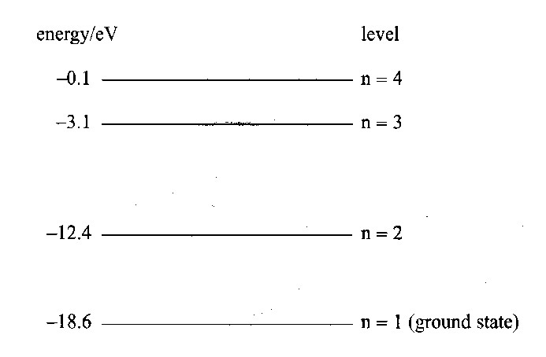

Photons of specific wavelengths are emitted from these atoms when they are **excited** by collisions with electrons.

One of the emitted photons has an energy of 9.92 x 10‑19J.

a) Determine which transition is responsible for this emitted photon. *(3 Marks)*

= *✓*

*✓*

*✓* Transition from n=2 to n=1

b) Draw an arrow on the energy level diagram to show the transition responsible for the emission of a photon with the shortest wavelength. *(1 Mark)*

**QUESTION 4 (5 Marks)** **Q5 WATP 2005**

The line spectrum from a fluorescent light consists of several bright lines on a dark background whereas the spectrum of sunlight consists of discrete dark lines on a coloured background. Explain this difference.

*Line spectrum is emission spectrum ✓*

*Emission spectrum results from electrons dropping to lower energy levels. ✓*

*Discrete dark lines are absorption spectrum ✓*

*Absorption spectrum results from electrons in gas moving to higher energy levels when light passes through. ✓*

*Coloured background is blackbody radiation ✓*

**QUESTION 5 (5 Marks)**  **Q11 WATP 2011**

The graph shows the X-ray spectrum from a target metal bombarded by electrons with a supply voltage of 33.0 kV

1. Circle on the X-ray spectrum diagram the line emission portion of the spectrum and explain briefly how it is formed.

Wavelength × 10-11 m

Intensity

(Photon count)

*When the electrons hit the anode it promotes electrons to a higher energy level. ✓*

*These characteristic peaks are emitted when the electrons drop back down to a lower energy level. ✓*

*(3 Marks)*

1. Sketch on the graph, the general shape of the X-ray spectrum if the supply voltage is decreased to 31.0 kV.

Wavelength × 10-11 m

Intensity

(Photon count)

*Characteristic lines in same place ✓*

*Lower energy spectrum (higher λ) ✓*

*(2 Marks)*

**QUESTION 6 (6 Marks)**

Is light a wave or a particle, and if it is a wave, what type of wave is it? Support your answer naming key experiments and phenomena.

*Light is both a wave and a particle*

*Youngs double slit ✓ experiment showed that light was a wave because it displayed the wave characteristics of diffraction and interference. ✓*

*The photoelectric effect ✓ shows light is a particle as increasing intensity of incident light does not give you photoelectrons if you are below the threshold frequency ie. Photoelectrons due to individual particle collision. ✓*

*Light is a transverse ✓ wave because it can be polarised. ✓*

**QUESTION 7 (5 Marks)** **Q11 2016 WACE Exam**

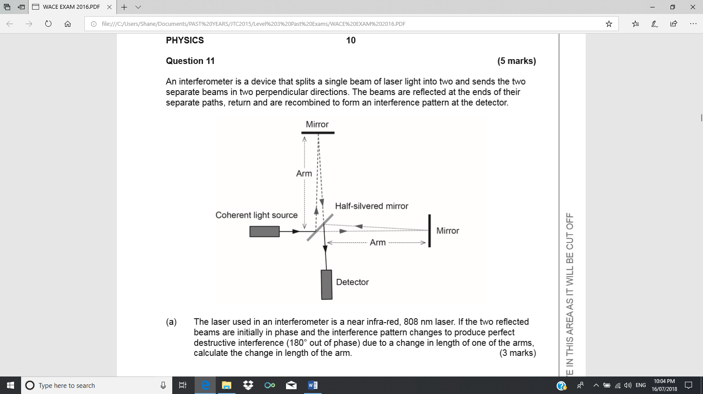

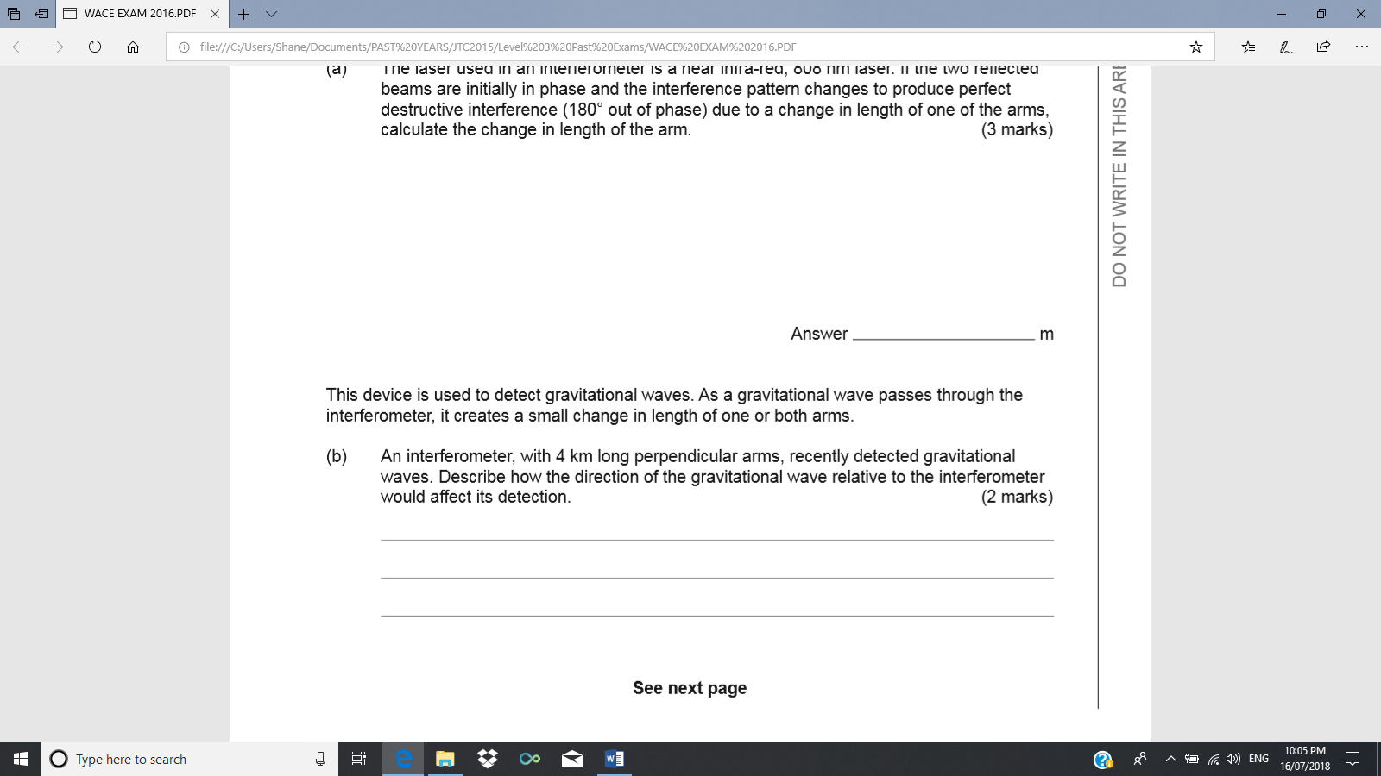

**QUESTION 8 (6 Marks)**

1. What is the de Broglie wavelength of an electron (*m* = 9.11  10-31 kg) in a 5.0 kilovolt X-ray tube (ignore relativistic effects)?

*✓*

*✓*

*✓*

⇒

*✓*

*λ*

*✓*

*= ✓*

*(6 Marks)*

1. [What happens to the de Broglie wavelength of the electron if its momentum is doubled?](https://www.proprofs.com/discuss/q/1262011/what-happens-the-broglie-wavelength-electron-its-momentum-do)

*The Wavelength halves. ✓*

*(1 Mark)*

**QUESTION 9 (13 marks)**  **Q4** **WATP 2006**

Consider the following diagram that shows the same collection of minerals in (a) daylight and (b) “black light”.

GREEN

YELLOW

BLUE

GREY

BROWN

WHITE

WHITE

BLUE

BLUE

BROWN

|  |  |
| --- | --- |
|  |  |

1. Complete the following sentence: The correct terminology for “black light” is

_____*__________*_______ and the phenomenon is called ____*_____________*__________. *(2 marks)*

The first 4 energy levels for a potassium mineral are shown (not to scale) as follows.

___________________________E4 = 3.29 eV

___________________________E3 = 2.61 eV

___________________________E2 = 1.52 eV

___________________________E1 = 0.00 eV

Could a sample of this potassium mineral display the phenomena in shown in (a) above? Justify your answer showing the necessary calculations.

*Smallest energy gap ✓ Frequency =*

*✓*

*Largest energy gap = 3.29 eV = 5.264 Frequency =*

*7.94 ✓*

*No. These frequencies are below UV ✓*

*(4 marks)*

c) Consider again the first 4 energy levels for the potassium mineral in (b). What energy photons would be detected if particles of the sample in its ground state were bombarded by

(i) photons of energy 2.65 eV;

*Nothing. Only the bombarding photons because this is not an exact energy level difference. ✓*

(ii) electrons of energy 2.65 eV?

*Photons of energy 1.52eV, 2.61eV ✓✓*

*(3 marks)*

d) If an electron was excited from the ground state to the 3.29 eV level:

(i) When it returned to the ground state what would be the wavelength of the photon emitted?

*✓*

*✓*

m *✓*

*(3 marks)*

(ii) To which region of the electromagnetic spectrum would the photon belong? (Visible light λ: 400 nm-700 nm)

*Ultraviolet ✓*

*(1 mark)*

**END OF TEST**